*A project report on*

# U-Net based Tooth Segmentation and Caries Detection in Digital Dental Radiography

*Submitted in partial fulfillment for the award of the degree of*

## Bachelor of Technology in Computer Science and Engineering

*by*

**Sreyas Rejil (20BCE1930)**



**SCHOOL OF COMPUTER SCIENCE AND ENGINEERING**

April,2024

# U-Net based Tooth Segmentation and Caries Detection in Digital Dental Radiography

*Submitted in partial fulfillment for the award of the degree of*

## Bachelor of Technology in Computer Science and Engineering

*by*

**Sreyas Rejil (20BCE1930)**



**SCHOOL OF COMPUTER SCIENCE AND ENGINEERING**

April,2024

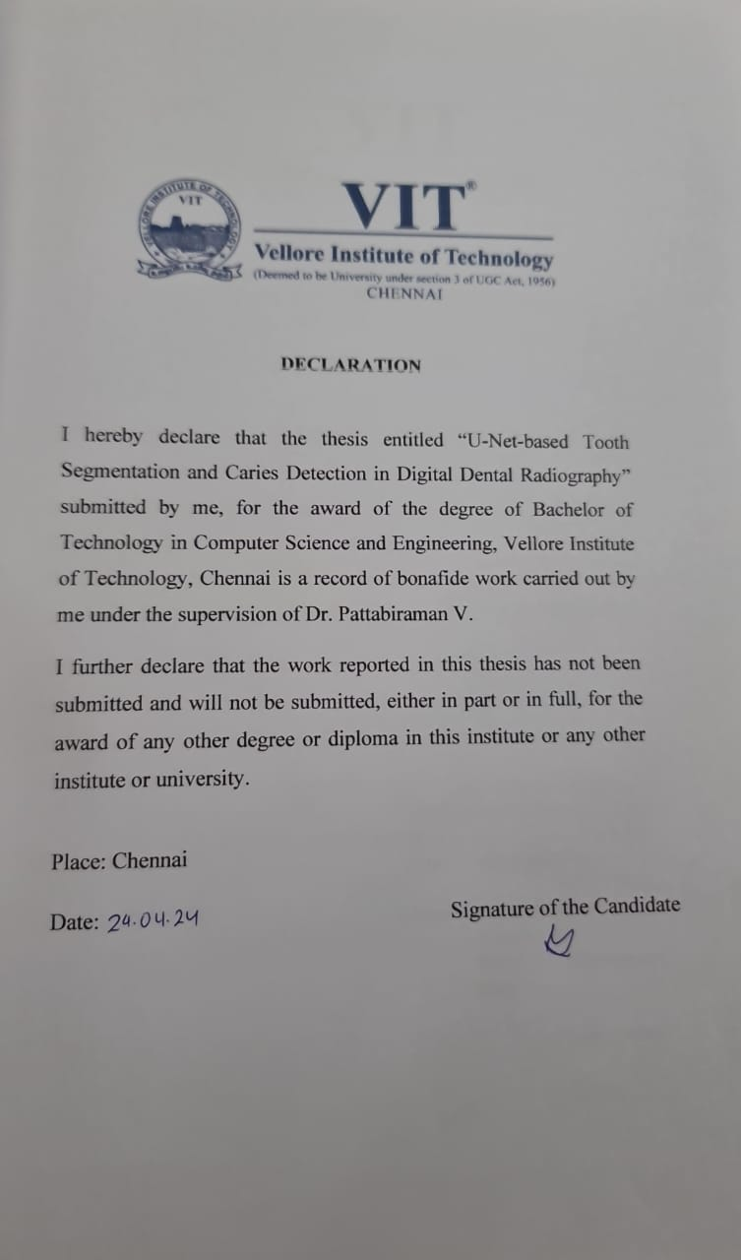

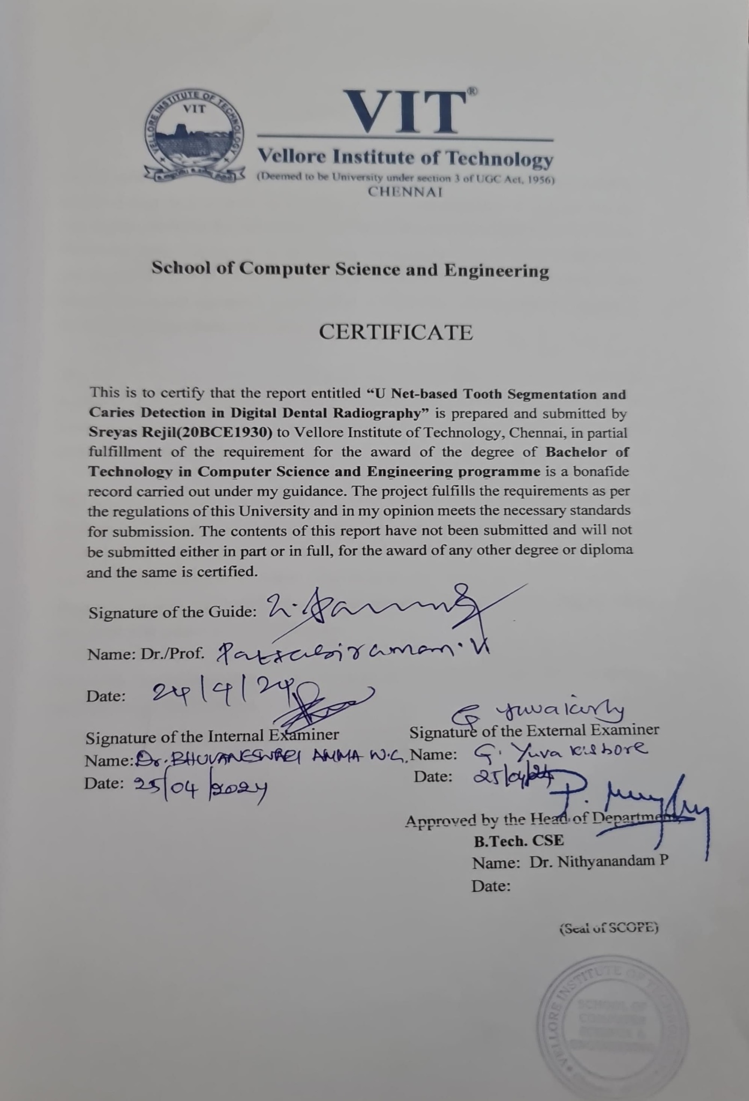

**ABSTRACT**

Dental caries, a pervasive global health concern, remains a challenge, necessitating advanced diagnostic methodologies. Dental X-ray radiography stands as a pivotal tool for radiologists, enabling the identification of dental diseases that elude visual detection. Within the realm of dental radiographs, the accurate segmentation of dental structures and pathologies emerges as a critical task. The manual annotation of these structures proves labor-intensive and susceptible to inter-observer variability, underscoring the imperative for automated segmentation methods.

This study introduces a novel approach employing a U-Net based architecture to expedite the segmentation of individual teeth and the detection of caries from bitewing radiographs. Leveraging both U-Net and U-Net++ models, we aim to enhance the efficiency of case identification and segmentation.

The primary objective of our model is to streamline the segmentation process, thereby accelerating the overall evaluation duration for patient diagnoses. By employing these models, computational resources are utilized more efficiently, allowing for rapid caries detection from radiographs within mere seconds. Our main goal is to facilitate the diagnostic process and enable clinicians to identify subtle caries and intricate dental structures with greater ease and efficiency.

Keywords : Tooth Segmentation, Dental Caries, Bitewing Radiographs, Deep Learning, Medical Image Segmentation, U-Net

*i*

**ACKNOWLEDGEMENT**

It is my pleasure to express with deep sense of gratitude to Dr.Pattabiraman V,Professor & Associate Dean Academic Research , School of Computer Science and Engineering, Vellore Institute of Technology, Chennai, for his constant guidance, continual encouragement, understanding; more than all, he taught me patience in my endeavor. My association with him is not confined to academics only, but it is a great opportunity on my part of work with an intellectual and expert in the field of Computer Science.

It is with gratitude that I would like to extend my thanks to the visionary leader Dr. G. Viswanathan our Honorable Chancellor, Mr. Sankar Viswanathan, Dr. Sekar Viswanathan, Dr. G V Selvam Vice Presidents, Dr. Sandhya Pentareddy, Executive Director, Ms. Kadhambari S. Viswanathan, Assistant Vice-President, Dr. V. S. Kanchana Bhaaskaran Vice-Chancellor, Dr. T. Thyagarajan Pro-Vice Chancellor, VIT Chennai and Dr. P. K. Manoharan, Additional Registrar for providing an exceptional working environment and inspiring all of us during the tenure of the course.

Special mention to Dr. Ganesan R, Dean, Dr. Parvathi R, Associate Dean Academics, Dr. Geetha S, Associate Dean Research, School of Computer Science and Engineering, Vellore Institute of Technology, Chennai for spending their valuable time and efforts in sharing their knowledge and for helping us in every aspect.

In jubilant state, I express ingeniously my whole-hearted thanks to Dr. Nithyanandam P, Head of the Department, B.Tech. CSE and the Project Coordinators for their valuable support and encouragement to take up and complete the thesis.

My sincere thanks to all the faculties and staffs at Vellore Institute of Technology, Chennai who helped me acquire the requisite knowledge. I would like to thank my parents for their support. It is indeed a pleasure to thank my friends who encouraged me to take up and complete this task.

Place: Chennai **Sreyas Rejil**

Date:

*ii*

## CONTENTS

**CONTENTS** iii

**LIST OF FIGURES** v

**LIST OF TABLES** vi

**LIST OF ACRONYMS** vii

**CHAPTER 1 INTRODUCTION**

* 1. BACKGROUND AND MOTIVATION 1
  2. PROBLEM STATEMENT 2
  3. CHALLENGES AND OBJECTIVES 2
  4. DATA AVAILABILITY AND USAGE 3
  5. OBJECTIVES AND FEATURES 3
  6. SCALABILITY AND INTEGRATION 4
  7. EVALUTION AND VALIDATION 4
  8. OVERVIEW 5

**CHAPTER 2**

**LITERATURE REVIEW**

* 1. LITERATURE REVIEW 6

*iii*

**CHAPTER 3 METHODOLOGY**

3.1 PROPOSED WORKFLOW 10

3.2 DATA COLLECTION 12

3.3 MODEL ARCHITECTURE 14

3.3.1 TOOTH SEGMENTATION MODEL 14

3.3.2 CARIES DETECTION MODEL 16

3.4 EXPERIMENTAL SETUP 17

3.5 EVALUATION METRICS 18

3.6 CHALLENGES 21

**CHAPTER 4**

**RESULTS AND DISCUSSION**

* 1. TOOTH SEGMENTATION MODEL 22

4.2CARIES DETECTION MODEL 25

**CHAPTER 5**

**CONCLUSION AND FUTURE WORK**

5.1CONCLUSION 30

* 1. FUTURE WORK 31

*iv*

### LIST OF FIGURES

* 1. PROPOSED WORKFLOW 22
  2. RADIOGRAPH IMAGE AND ITS SEGMENTED MASK 23
  3. BITE-WING RADIOGRAPH AND CORRESPONDING LABELS 24
  4. RADIOGRAPH IMAGE POST-CROPPING 24
  5. MODEL ARCHITECTURE DIAGRAM – TOOTH SEGMENTATION 24
  6. MODEL ARCHITECTURE DIAGRAM – CARIES DETECTION 25
  7. MODEL OUTPUT AFTER 500TH EPOCH – TOOTH SEGMENTATION 29
  8. MODEL OUTPUT AFTER 8000 EPOCHS – TOOTH SEGMENTATION 30
  9. METRICS VISUALIZATION OF TOOTH SEGMENTATION MODEL 30

1.10 TOOTH SEGMENTATION MODEL PREDICTION 31

1.11 TRAINING –VALIDATION CURVE -CARIES DETECTION MODEL 32

1.12 IOU CURVE – CARIES DETECTION MODEL 33

1.13 MODEL PERFORMANCE – CARIES DETECTION MODEL 34

1.14 REALTIME USECASE – CARIES DETECTION MODEL 35

*v*

**LIST OF TABLES**

1 HYPERPARAMETER VALUES OF MODEL 27

2 COMPARISON OF MODEL METRICS - CARIES DETECTION 33

*vi*

**LIST OF ACRONYMS**

1. CNN - Convolutional Neural Network
2. GAN - Generative Adversarial Network
3. IOU - Intersection over Union
4. GPU - Graphics Processing Unit
5. PIL - Python Imaging Library
6. U-Net - U-Net (Convolutional Network)
7. BCE - Binary Cross-Entropy
8. Dice - Sørensen–Dice coefficient

*vii*

**Chapter 1**



**Introduction**

1.1 BACKGROUND AND MOTIVATION

Dental caries, a prevalent disease affecting many individuals, arises from the fermentation of foods by bacteria, leading to the production of acids that dissolve tooth minerals. The initial stages of caries manifestation, detectable as white-spot lesions visible to the naked eye, underscore the significance of early identification. As lesions progress into the enamel, dental radiographs serve as invaluable tools for detection. [1] At this stage, intervention through remineralization can potentially halt the advancement of caries, forestalling the development of cavities and subsequent tooth loss.

The importance of early detection and intervention cannot be overstated, as it mitigates the deleterious consequences of untreated caries. While visual inspection supplemented by a mirror remains a primary means of detection, the utilization of dental radiographs offers a more comprehensive assessment. Nonetheless, the performance of radiographic detection is dependent upon several variables, including viewing conditions, radiograph quality, and the expertise of examiners [2].

Beyond detection, the segmentation of individual teeth is an important task in dental image analysis. Accurate segmentation is indispensable for precise diagnosis, treatment planning, and elucidating the underlying tooth structure. However, the inherent complexity of dental radiographs, which often include extraneous anatomical features, poses a challenge to effective segmentation.[3]. It is difficult to manually segment each individual tooth by clinicians without the aid of an automated segmentation tool.

Modern dentistry relies on a combination of visual examination and diagnostic tools for comprehensive caries detection. Dentists employ visual inspection to identify visible caries, but often, the initial stages of decay are not visually apparent. Radiographic imaging becomes indispensable in these cases, allowing for the identification of caries lesions not visible to the naked eye.

Despite advancements in diagnostic technologies, detecting hidden caries remains a challenge. Some lesions may be sub-surface or in between teeth, making them elusive during conventional visual examinations. Radiographs, particularly bitewing and periapical views, aid in unveiling this hidden caries, enabling early intervention.

1.2 PROBLEM STATEMENT

Recent advancements in artificial intelligence have revolutionized the detection of caries, offering promising avenues for enhanced diagnostic capabilities. By utilizing machine learning and deep learning frameworks, various studies have successfully trained models to detect caries from radiographs, thereby augmenting clinicians' decision-making processes with a degree of efficiency and consistency.

We plan on using a U-Net architecture-based segmentation model, which takes in the bitewing radiograph images as inputs and performs segmentation based on the model chosen, Caries Detection or Tooth Segmentation.

While dealing with deep learning models, availability of a large dataset is crucial in order for the neural network to learn the intricate features and details from the input, especially in the medical field and our task it is important to learn the low-level and high-level features of the images to allow the model to create accurate and reliable segmentation outputs.

1.3 CHALLENGES AND OBJECTIVES

Acquiring a large dataset especially in medical fields is quite difficult due to ethical and privacy constraints. [15] show that models tend to generalize better and produce better outputs when given larger and more diverse datasets, methods such as data augmentation, utilizing GAN’s to produce synthetic images all are shown to increase the model performance.

1.4 DATA AVAILABILITY AND USAGE

All data utilized in this project are sourced from publicly available repositories. The inclusion of images in our dataset is contingent upon obtaining consent from the respective patients, ensuring adherence to ethical guidelines. It is noteworthy that no personally identifiable information is incorporated into the dataset, thus safeguarding patient privacy and confidentiality.

Data Augmentation methods are quite common in deep learning tasks, especially when dealing with smaller datasets. When dealing with radiograph images, we have to be careful when performing augmentation operations to ensure that the overall structure and features of the image does not get too distorted or ruined. We utilize augmentation methods such as rotations, flipping, Gaussian noise, etc. To artificially induce data.

1.5 OBJECTIVES AND FEATURES

Our aim is to create a model which is able to efficiently segment tooth and detect caries if present to aid the clinicians in performing their diagnosis. In a study [5] involving the training of neural networks on bitewing radiographs, similar to those employed in our research, clinicians exhibited improved judgment when aided by these segmented images. This assistance contributed to more accurate early diagnosis and detection, particularly in cases belonging to the initial and moderate caries groups.

This can not only speed up the overall process, by removing the need for manual segmentation which is usually done using professional segmentation software, but also reduces the manpower needed in the entire process. Our model can easily be exported and run to produce the segmented output in under a second in most modern GPU’s.

Two distinct models are released as part of this project: a tooth segmentation model and a caries detection model, both of which employ a U-Net-based architecture.

The tooth segmentation model is trained exclusively on radiographs and their corresponding segmented mask images. This training approach is adopted due to the availability of a larger dataset conducive to effective model training. By segmenting each tooth individually, this model facilitates a comprehensive understanding of root structures, shapes, and other pertinent anatomical features discernible from radiographs.

In contrast, the caries detection model faces a scarcity of suitable training images. To address this challenge, a pre-trained model is utilized, with experimentation conducted using various types of encoders. Leveraging pre-trained models allows for the transfer of knowledge from existing datasets to enhance the caries detection capabilities of our model, compensating for the limited availability of training data specific to caries detection.

1.6 SCALABILITY AND INTEGRATION

Upon completion of training and evaluation of the model's metrics, its deployment for the segmentation and identification of caries by medical practitioners becomes readily feasible. The model can be exported and executed on any machine equipped with contemporary hardware and running Python versions 3.7.0 or later. Importantly, our model facilitates segmentation without necessitating any additional coding. The ability of the model's performance is also dependent upon the hardware employed, with segmentation achievable in less than a second on modern hardware featuring robust GPU capabilities.

1.7 EVALUATION AND VALIDATION

Proper validation of medical segmentation models is imperative prior to their deployment in real-world scenarios. It is essential to ensure that the model is trained on a sufficiently large sample of images to facilitate robust generalization and accurate segmentation.

Various metrics, including Dice Loss, Precision and Accuracy, are employed to assess the accuracy and performance of our models on both the training and validation datasets. These metrics enable an objective evaluation of the model's effectiveness in delineating anatomical structures and detecting pathological conditions. Detailed findings and metrics pertaining to the performance of our models will be presented in subsequent sections, elucidating their ability in medical image segmentation tasks.

1.8 OVERVIEW

The project aims to develop and deploy two distinct models for dental image analysis: a tooth segmentation model and a caries detection model. Utilizing a U-Net-based architecture, these models are designed to enhance the efficiency and accuracy of dental image interpretation. The tooth segmentation model focuses on segmenting individual teeth from radiographs to provide a comprehensive understanding of dental anatomy, while the caries detection model aims to identify and delineate carious lesions from dental radiographs.

To ensure the reliability and effectiveness of the models, rigorous validation procedures are conducted. This involves training the models on large datasets of dental images and evaluating their performance using metrics such as Dice Loss and Precision. By employing these metrics, the models' accuracy and generalization capabilities can be quantitatively assessed, enabling informed decisions regarding their deployment in real-world clinical settings.

The project acknowledges the importance of ethical considerations, particularly concerning patient privacy and consent. All data utilized in the project are sourced from publicly available repositories, with patient consent obtained for the inclusion of their images in the dataset. Moreover, measures are implemented to ensure the anonymity of patients and the confidentiality of their personal information throughout the data processing pipeline.

Overall, the project aims to advance the field of dental image analysis by developing and validating state-of-the-art segmentation models capable of aiding clinicians in diagnosing dental conditions more effectively and efficiently. Through rigorous experimentation and validation, we aim to demonstrate the reliability of the proposed models, paving the way for their integration into routine clinical practice

**Chapter 2**

**Literature Review**

Dental caries, a common affliction affecting numerous individuals, stems from bacterial fermentation of dietary substances, resulting in the generation of acids that erode tooth minerals. Early stages of caries, discernible as white spot lesions visible to the unaided eye, underscore the critical importance of timely identification. With progression into the enamel, dental radiographs emerge as pivotal diagnostic aids [1]. These images facilitate the detection of caries at a stage where remineralization interventions can impede further deterioration, thus averting the formation of cavities and subsequent tooth loss.

Understanding the significance of spotting dental issues early on is crucial, as it can help prevent the negative impacts of untreated cavities. While traditional methods like visually inspecting teeth with mirrors are common, using dental X-rays provides a more thorough assessment. However, relying on X-rays for diagnosis comes with its challenges, including factors like how well the X-ray is viewed, the quality of the image, and the skill level of the person interpreting it [2].

Various deep learning methods have been utilized in dentistry to aid in diagnosis and research,[16] showed that these models are highly capable of reducing the workload and diagnosis time while increasing the overall effectiveness and accuracy of the treatment. Models have been built to aid in various fields of dentistry including operative dentistry, orthodontics, prosthodontics etc. and have been shown to be effective.

Historically, segmentation tasks relied on classical machine learning techniques until the advent of more advanced approaches like convolutional neural networks (CNNs) [11]. The introduction of deep learning methods marked a substantial leap forward in achieving enhanced performance for automatic segmentation. Currently the usage of deep learning methods is on the rise among researchers, their increase in popularity and usage can be attributed to better performance and efficiency particularly in complex image segmentation tasks in medical research, where understanding and generalizing on the complex structure and details are important to generate accurate results that could be utilized by professionals.

In their research, [4], employed a deep CNN algorithm to detect caries following training on a dataset comprising 3000 periapical radiographic images. By implementing transfer learning, they utilized a Google Net Inception v3 CNN network as the foundational model.

The study demonstrated the working of employing a pre-trained model in deep learning segmentation tasks, particularly in scenarios characterized by limited availability of extensive datasets. Notably, their approach yielded a commendable accuracy rate of 89.0 The concept of U-Net-based medical segmentation, as introduced by [9], revolutionized image segmentation by training on a compact dataset augmented through various methods. Their outcomes surpassed those of prior methods, demonstrating efficient image segmentation.

The U-Net architecture employs an encoder-decoder structure with skip connections, facilitating the integration of both high and low-level features. Capitalizing on this model, [10] applied convolutional neural networks to segment individual teeth, achieving an impressive accuracy rate of 97. For caries detection, superior results are achieved when employing transfer learning on a pre-trained model.

This strategy proves advantageous, particularly when confronted with a scarcity of images, rendering training a custom model ineffective due to the data-intensive nature of neural networks, as outlined in [8]. Adopting this method not only conserves computational resources but also reduces the overall time investment without compromising performance.

In a study [2] involving the training of neural networks on bitewing radiographs, similar to those employed in our research, clinicians exhibited improved judgment when aided by these segmented images. This assistance contributed to more accurate early diagnosis and detection, particularly in cases belonging to the initial and moderate caries groups.

The importance of DL-based semantic segmentation methods in medical image analysis is underscored by a study conducted by [6]. In their research, they employed a residual U-Net-based network, which contributed to enhanced feature representation. Notably, this model outperformed conventional segmentation models like SegNet and U-Net across diverse datasets, emphasizing its efficacy in the field.

In a study [5], employed a modified convolutional neural network (CNN) model known as nnU-U-Net to detect caries lesions. The model was trained on a dataset comprising 1160 dental panoramic images, with caries lesions delineated by circles. Upon evaluation, the model achieved a Dice coefficient of 0.663 and an Intersection over Union (IoU) of 0.785 on the test dataset. The findings suggested that the nnU-U-Net model demonstrated comparable performance to expert dentists in the detection and classification of caries lesions. This underscores the significance of automated segmentation and deep learning models in augmenting diagnostic and treatment processes within the field of dentistry. This assistance contributed to more accurate early diagnosis and detection, particularly in cases belonging to the initial and moderate caries groups.

The importance of DL-based semantic segmentation methods in medical image analysis is shown by a study conducted by [12]. In their research, they employed a residual U-Net-based network, which contributed to enhanced feature representation. Notably, this model outperformed conventional segmentation models like SegNet and U-Net across diverse datasets, emphasizing its usefulness in the field.

The U-Net 3+, a model introduced in [13], maximizes the benefits of full-scale skip connections and deep supervisions. This design enables the model to seamlessly integrate low- level features with high-level semantics and feature maps. The adapted architecture exhibited superior performance compared to traditional U-Net models, particularly on specific datasets.

Teeth U-Net [19] utilizes a squeeze excitation module and a dense skip-layer connection to reduce semantic gap. Most publicly available dental datasets are of low quality, and not suitable for training deep learning models. A multiscale aggregation attention block was utilized by them to help the model learn the intricate features from these images better.

The dataset for this research will be sourced from a recent investigation conducted by Y. Zhang et al. [6]. The study successfully acquired a limited set of paediatric caries radiographs, which will serve as the foundation for training our U-Net model tooth segmentation model. A different dataset will be utilized for caries segmentation. Their study was conducted with privacy and ethical concerns in mind, all patients included in the dataset have given their consent for the use of their data for scientific research. Utilizing a dataset reviewed and approved by the ethics committee, relieves us of the task of procuring data manually.

The radiographic images obtained from the study underwent a meticulous anonymization process and were subject to manual review by an independent third party. This comprehensive review ensured the removal of any identifiable patient information, thereby preserving the privacy of individuals within the dataset. Furthermore, the dataset received scrutiny and approval from an independent ethics committee, reinforcing the ethical soundness of utilizing this data for our research endeavors. This meticulous approach to data curation aligns with established ethical standards in medical research.

**Chapter 3**



**Methodology**

Our project strategy involves the development of two distinct models utilizing a shared underlying architecture. These models are intended to serve different purposes and will be trained on separate datasets to align with their respective objectives. The first model is dedicated to tooth segmentation and will be exclusively trained on our dataset. Its primary function is to segment individual teeth based on input radiograph images. Conversely, the second model will focus on caries detection and will undergo training on a different dataset comprising bitewing radiograph images while performing transfer learning.

By adopting this approach, we aim to tailor each model to its specific task while leveraging the inherent capabilities of the chosen architecture. The segmentation model will facilitate the detailed delineation of tooth structures, enabling a deeper understanding of dental anatomy and aiding in diagnostic and treatment planning processes. On the other hand, the caries detection model aims to identify and classify caries lesions within radiographic images, thereby enhancing clinicians' ability to detect and manage dental caries effectively.

Through the utilization of separate datasets and training procedures, we aim to optimize the performance of each model according to its designated task. By harnessing the power of deep learning and leveraging a shared architecture, we seek to develop robust and efficient solutions for dental image analysis, ultimately contributing to improved patient care and clinical outcomes

3.1 PROPOSED WORKFLOW

The initial step in our proposed workflow as shown in figure 1 involves data preprocessing and augmentation, essential for enhancing the quality and quantity of the dental radiography dataset. Given the intricacies of dental images and the need for precise segmentation, preprocessing techniques such as normalization and resizing are applied to standardize the images and ensure consistency across the dataset. Additionally, augmentation methods such as rotation, flipping, and brightness adjustments are employed to augment the dataset, effectively increasing its diversity and robustness. These preprocessing and augmentation steps are crucial for preparing a comprehensive dataset that facilitates the training of accurate and reliable segmentation models.

Following data preprocessing and augmentation, the augmented dataset is loaded into memory, and the U-Net based segmentation model is initialized. The model initialization phase involves configuring the architecture and hyperparameters of the U-Net model, ensuring optimal performance during training. Proper initialization of the model sets the stage for effective learning, enabling the model to capture the intricate features present in dental radiographs.

With the dataset loaded and the model initialized, the training phase commences, where the U-Net based segmentation model learns to accurately delineate individual teeth and detect caries from dental radiographs. The training process involves iteratively presenting batches of augmented images to the model, which learns to optimize its parameters through backpropagation and gradient descent. As the training progresses, the model gradually improves its segmentation and caries detection capabilities, fine-tuning its parameters to better align with the ground truth annotations.

Upon completion of the training phase, the trained model is evaluated using various metrics to assess its performance and effectiveness in dental image segmentation. Metrics such as Intersection over Union (IOU), Precision, and Dice coefficient are computed to quantify the model's segmentation accuracy and caries detection capabilities. The evaluation process involves comparing the model's predictions with ground truth annotations, providing valuable insights into its strengths and limitations

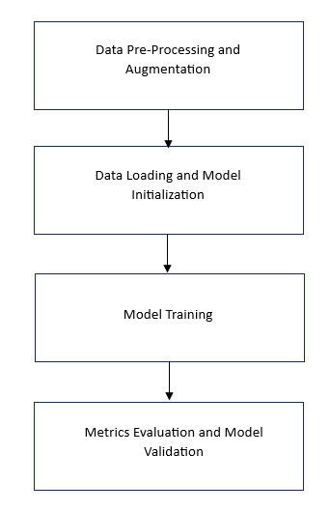

Figure 1

Proposed Workflow

3.2 DATA COLLECTION

In this project, we employ publicly available panoramic dental image datasets for our analysis. The tooth segmentation dataset comprises anonymized dental radiograph images paired with segmented masks, a process executed by clinicians using ElSeg [6]. Notably, the radiographic images sourced from this dataset have undergone rigorous anonymization procedures and were subject to manual review by an independent third party to ensure compliance with privacy and confidentiality standards.

Figure 2 shows a sample input bitewing radiograph image along with its segmented mask. The mask is able to give a better visualization of the tooth’s structure, depth and other intricate details which might not be easily visible from the radiograph

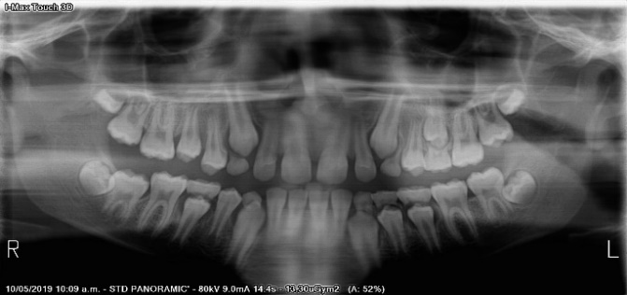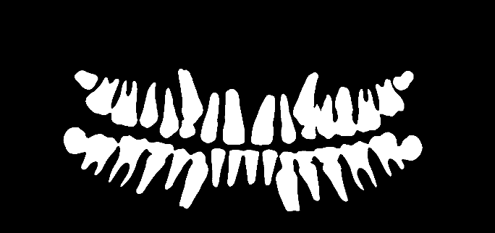

Figure 2

Radiograph Image and Its Segmented Mask

The dataset utilized for caries detection is sourced from a publicly released paper [14] and consists of bitewing radiograph images similar to those in the tooth segmentation dataset. However, in this dataset, regions affected by caries have been meticulously segmented by professional clinicians. By using these datasets, we aim to develop and validate models capable of accurate tooth segmentation and caries detection, thereby enhancing diagnostic capabilities and treatment planning processes in dentistry.

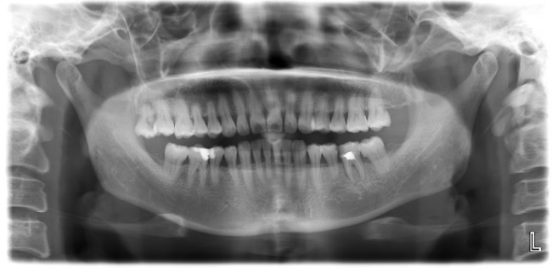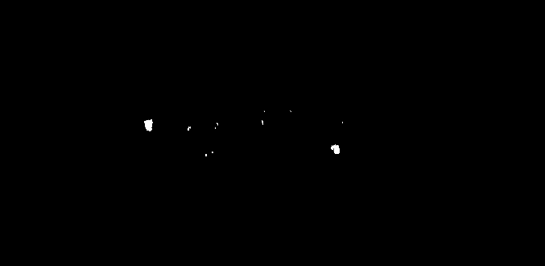

Figure 3

Bite-Wing Radiograph and Corresponding Labels showcasing caries

Figure 3 shows the bitewing radiograph image and on the right the segmented mask showing caries (in white). In order to enhance the model's ability to focus on relevant dental features, we perform a necessary cropping on all radiograph images as shown in figure 4.

This cropping process excludes extraneous details such as cheekbones, lower jaw bones, and other non-dental elements that do not contribute to caries detection. By eliminating these irrelevant external features, we ensure that the model's attention is directed solely towards the dental structures of interest. This targeted approach facilitates more effective learning and feature extraction, thereby improving the model's performance in caries detection tasks.

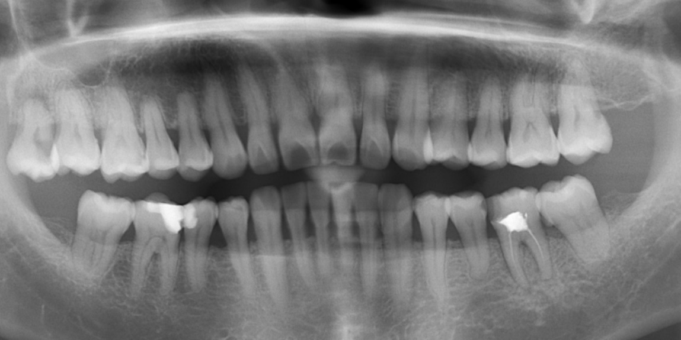

Figure 4

Radiograph Image Post-Cropping

* 1. MODEL ARCHITECTURE

3.3.1 TOOTH SEGMENTATION MODEL

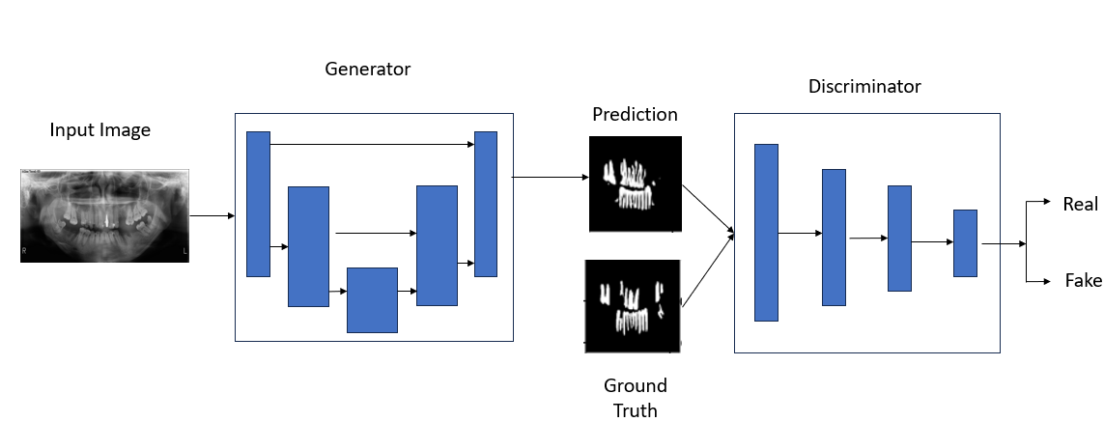

Figure 5

Model Architecture Diagram

The U-Net architecture, depicted in Figure 5, is widely recognized for its efficiency in various image segmentation tasks. Its design comprises two principal pathways: the contracting path situated on the left and the expanding path on the right.

The contracting path, also known as the encoder, resides on the left segment of the U-Net architecture. This segment employs a succession of convolutional and pooling layers to systematically reduce spatial dimensions while concurrently capturing salient high-level features.

Conversely, the expanding path functions as the decoder and occupies the right side of the architecture. Consisting of transposed convolutions and up-sampling layers, this pathway progressively restores spatial dimensions. Moreover, it integrates contextual information derived from the contracting path, ensuring comprehensive feature extraction and semantic understanding throughout the segmentation process.

In addition to the conventional U-Net architecture, U-Net++ presents an advanced iteration engineered to enhance segmentation efficacy. U-Net++ introduces significant enhancements, including full-scale skip connections, which establish connections between layers operating at the same resolution. This strategy effectively merges low-level and high-level features, thereby enriching the representation learned by the network.

U-Net++ incorporates deep supervisions, a novel approach that integrates additional pathways featuring intermediate predictions at multiple scales. This implementation aims to mitigate information loss encountered during the encoding and decoding stages. By leveraging these supplementary paths, U-Net++ ensures comprehensive feature extraction and semantic understanding across different spatial scales, ultimately enhancing segmentation performance.

3.3.2 CARIES DETECTION MODEL

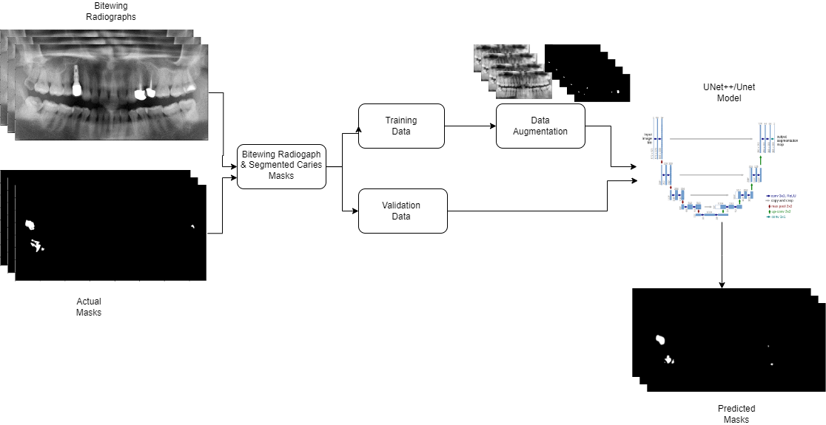

Figure 6

Model Architecture Diagram

Studies done on caries detection usually are done by custom training on a larger unpublicized medical dataset, The models commonly used were CNN and its variations. Using bitewing radiographs meant that a larger amount of unwanted data was present for the model to learn from such as cheek bones, jaw region etc. [15] showed that high resolution images were required in case of bitewing radiographs to achieve good performance.

In the development of the caries detection model, we explored three distinct approaches: leveraging a U-Net++ architecture coupled with an EfficientNetB0 model as the encoder, utilizing a U-Net++architecture with an EfficientNetB0 backbone, and employing a U-Net model with a ResNet34 encoder.

Each approach involved initializing the encoder with weights sourced from the ImageNet dataset, providing a solid foundation for feature extraction. To optimize the model, we adopted the DiceLoss function as the loss function and employed the Adam optimizer, a popular choice for training deep neural networks.

To handle the dataset efficiently and prevent memory constraints, we implemented a data generator class. This class facilitated the seamless integration of the dataset into the main memory during experimentation. Subsequently, the dataset was partitioned into distinct subsets for training, testing, and validation purposes. These subsets were then fed into the respective U-Net models for training as shown in figure 6.

Following the training phase, we meticulously evaluated the performance of each model. This evaluation process involved utilizing various metrics to assess the model's effectiveness in detecting caries lesions from radiographic images. By comprehensively evaluating each approach, we aimed to identify the most effective strategy for caries detection in dental radiographs.

* 1. EXPERIMENTAL SETUP

For the tooth segmentation model, we adopted a U-Net architecture trained exclusively on our dataset of dental radiograph images paired with segmented masks. The encoder utilized weights pre-trained on the ImageNet dataset to facilitate feature extraction. To optimize the model, we employed the DiceLoss function as the loss function and utilized the Adam optimizer.

A data generator class was implemented to efficiently manage the dataset, allowing for seamless integration into the main memory during experimentation. The dataset was partitioned into distinct subsets for training, testing, and validation, with each subset fed into the U-Net model for training. Following training, the model's performance was evaluated using various metrics to gauge its effectiveness in accurately segmenting individual teeth from radiographic images.

For the caries detection model, we explored three different approaches: a U-Net++ architecture coupled with an EfficientNetB0 model, a U-Net++ architecture with an EfficientNetB0 backbone, and a U-Net model with a ResNet34 encoder. In each approach, the encoder was initialized with weights sourced from the ImageNet dataset to facilitate feature extraction.

The DiceLoss function was employed as the loss function, and the Adam optimizer was utilized for model optimization. To efficiently handle the dataset, a data generator class was implemented, allowing for the dataset to be fitted into the main memory during experimentation. The dataset was partitioned into training, testing, and validation subsets, with each subset input into the respective U-Net models for training.

Post-training, the performance of each model was rigorously evaluated using various metrics to assess its efficiency in detecting caries lesions from radiographic images. Through systematic experimentation and evaluation, we aimed to identify the most effective approach for caries detection in dental radiographs.

The model construction was executed using Keras and TensorFlow, with the experimentation conducted on Kaggle and Google Colaboratory environments, both operating with Python version 3.12.0 and TensorFlow version 2.15.0. The specific hyperparameters selected for the experiment are outlined in Table I.

TABLE I

HYPERPARAMETER VALUES OF MODEL

|  |  |
| --- | --- |
| EPOCHS | 100 |
| BATCH SIZE | 8 |
| OPTIMIZER | ADAM |
| LOSS FUNCTION | DICE LOSS |
| METRICS | IOU, ACCURACY, PRECISION, DICE |

Top of Form

3.5 EVALUATION METRICS

Several evaluation criteria are employed to assess the effectiveness of the implemented models in dental image analysis. Among these, the dice coefficient stands out as a prominent measure for evaluating medical image segmentation performance. Additionally, the Intersection over Union (IOU) and precision metrics are calculated to further gauge the segmentation performance of our models. In each evaluation metric, a higher score corresponds to superior segmentation accuracy and effectiveness.

In the evaluation process, the True Positive (TP) indicates a correct match between the predicted caries mask and the actual caries region within the image. Conversely, True Negative (TN) signifies alignment between the predicted non-caries area and the actual absence of caries. False Positive (FP) denotes instances where the model incorrectly predicts the presence of caries, while False Negative (FN) represents scenarios where the model fails to detect actual caries. By considering these metrics collectively, a comprehensive assessment of the model's segmentation accuracy and effectiveness can be achieved.

In image segmentation tasks, metrics such as Dice coefficient, Intersection over Union (IOU), and Precision play crucial roles in evaluating the effectiveness of segmentation algorithms. The Dice coefficient measures the overlap between the predicted segmentation mask and the ground truth mask, providing insights into the accuracy of segmentation boundaries.

IOU calculates the intersection area divided by the union area of the predicted and ground truth masks, offering a measure of segmentation accuracy that accounts for both true positive and false positive predictions. Precision, on the other hand, quantifies the proportion of correctly predicted positive instances among all predicted positive instances, emphasizing the model's ability to avoid false positives.

*Dice Coefficient*

Dice = $\frac{2*TP}{2*TP+FP+FN}$

(1)

*Intersection Over Union*

IOU = $\frac{TP}{TP+FP+FN}$

(2)

*Precision*

Precision = $\frac{TP}{TP+FP}$

(3)

These metrics are particularly relevant in scenarios where image segmentation involves distinguishing subtle features amidst predominantly homogeneous backgrounds, such as in medical imaging or satellite imagery. In such cases, the segmentation task may involve delineating objects or regions of interest against a background that is largely uniform or predominantly black. In these scenarios, traditional accuracy metrics may not adequately capture the performance of segmentation algorithms, as they tend to yield high accuracy due to the abundance of negative instances (i.e., background pixels) in comparison to positive instances.

As a result, metrics like Dice coefficient, IOU, and Precision offer more nuanced assessments of segmentation accuracy by focusing on the correct delineation of target objects or regions, thus providing more informative evaluations of segmentation models in scenarios where imbalanced class distributions are prevalent.

3.6 CHALLENGES

Neural networks demand a substantial volume of images for effective training and robust generalization across data. Their computational demands necessitate ample video memory and suitable graphics cards for efficient training. To address these requirements, we leverage online cloud computation platforms such as Google Colaboratory and Kaggle Notebooks, which provide free compute resources for model training.

However, a notable challenge arises from the lack of diversity in the datasets available for training. While techniques like image augmentations and translations can expand the dataset size, they do not introduce new information for the model to learn from. This limitation is particularly pronounced in medical fields, where assembling large datasets is inherently challenging due to ethical and privacy considerations. Balancing the need for data volume with patient confidentiality presents a complex dilemma in dataset creation.

Moreover, hardware constraints further compound the issue, necessitating a reduction in image resolution and size during training to remain within the allocated GPU resources provided by the cloud platform. This compromise in image quality underscores the trade-offs inherent in leveraging cloud-based computation for neural network training in resource-constrained environments.

**Chapter 4**

**Results and Discussion**

4.1 TOOTH SEGMENTATION MODEL

In the tooth segmentation model, the utilization of a U-Net based Generative Adversarial Network (GAN) yielded impressive generalization capabilities, particularly on a larger dataset. The model demonstrated substantial performance metrics during validation, with an accuracy of 0.9722, precision of 0.8794, and recall of 0.8736. The availability of a more extensive dataset enabled the U-Net-based GAN to generalize better, effectively learning the nuances and complexities inherent in dental images.

The model’s efficiency is notable, as it is capable of segmenting images with recent GPU acceleration in under a second. This efficiency is crucial for real-time applications, allowing for rapid analysis and segmentation of dental radiographs.

After undergoing over 8000 epochs of training, our model demonstrated significant progress in capturing fine details and intricacies present within the training dataset. Visual inspection of the model's performance revealed its ability to discern subtle features and accurately segment objects of interest.

Figure 7,8 illustrates the training progress, depicting the model's increasing proficiency with each epoch, showing the actual segmentation on top, and the model’s prediction on the bottom. As the number of epochs increases, the model showcases enhanced generalization capabilities, resulting in improved segmentation accuracy and overall performance. Through iterative training iterations, the model effectively learns to adapt and refine its segmentation predictions, ultimately achieving greater accuracy and robustness in handling diverse image data.

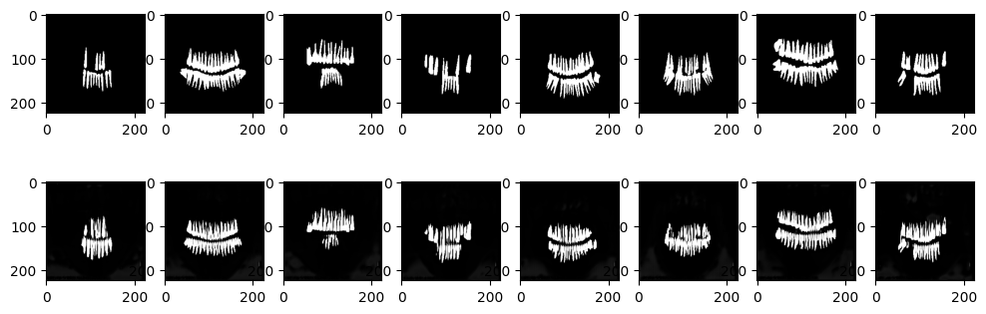

Figure 7

Model output after 500th Epoch

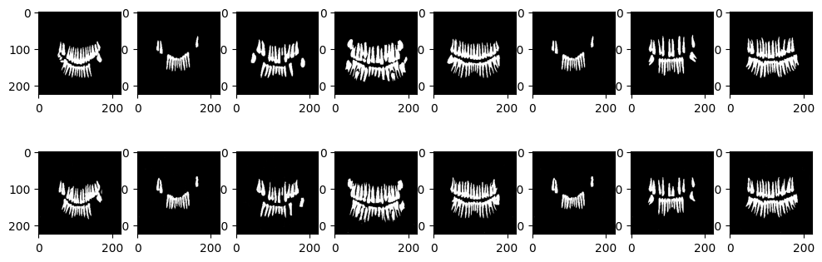

Figure 8

Model output after 8000 epochs

After completing the initial training phase, we proceeded to shuffle the dataset once again and initiated a fine-tuning process for our model. This fine-tuning involved retraining the model on the shuffled dataset for an additional 200 epochs, employing early stopping to prevent overfitting and ensure optimal performance. Figure 9 visualizes the various metrics for the fine-tuning phase, we can clearly see the early-stopping work and stop training once validation precision starts increasing, indicating over-fitting.

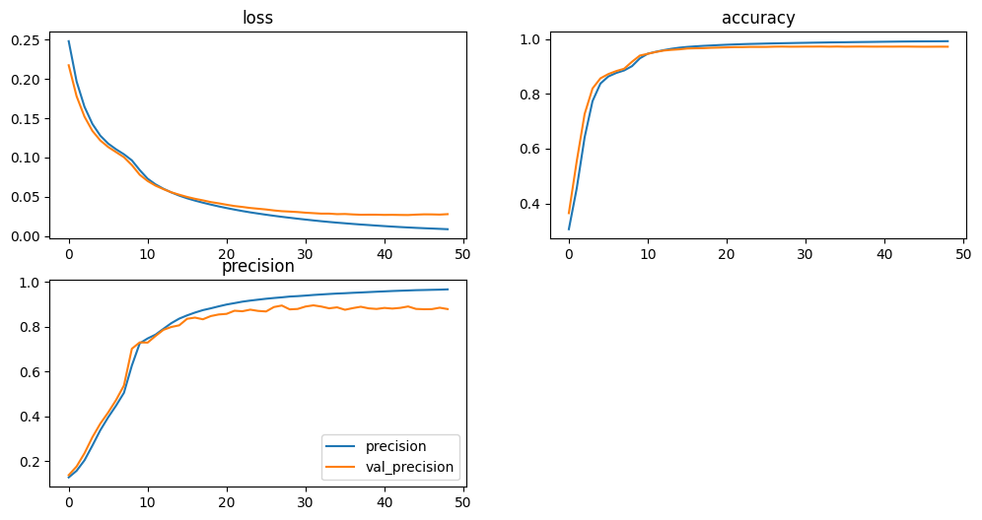

Figure 9

Metrics Visualization of Tooth Segmentation Model

Figure 10 showcases the input radiograph alongside the predicted masks generated by our model, demonstrating its capability to effectively extract and represent the structure of each individual tooth with a high degree of accuracy. While the model exhibits proficient performance in delineating tooth structures, some extraneous features may still require further refinement.

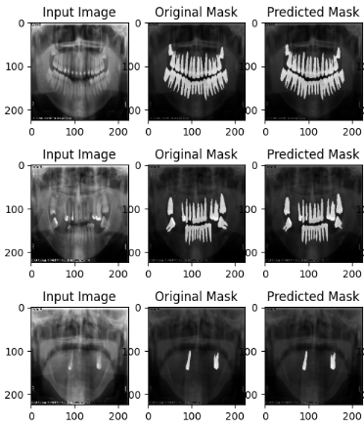

Figure 10

Model Prediction

4.2 CARIES DETECTION MODEL

In our approach to the segmentation task, we incorporated three distinct pre-trained models as the encoders within the U-Net architecture, serving as the foundational framework for our models. Each model underwent training for fewer than 200 epochs, carefully monitoring the onset of overfitting to ensure optimal performance.

Due to the relatively limited size of our dataset in comparison to the tooth segmentation model, we opted for transfer learning as a strategy, as it is better in leveraging pre-existing knowledge from the pre-trained models. Transfer learning demonstrated superior results compared to training models from scratch, allowing our models to effectively capitalize on the learned representations from the pre-trained encoders. This approach facilitated enhanced learning and adaptation to the segmentation task, enabling our models to achieve higher levels of performance within a constrained training timeframe.

All three models exhibited comparable training-validation curves, as illustrated in Figure 11. Notably, these curves plateaued around 75 epochs, indicating a stabilization of performance. Subsequent epochs showed minimal improvement, with the models eventually exhibiting signs of overfitting.

Several factors may contribute to this observed phenomenon, including the limited diversity of distinct data within our dataset, which may restrict the model's ability to learn generalized representations. Additionally, the choice of hyperparameters may influence model performance, with suboptimal values potentially impeding learning efficiency. Despite these challenges, the observed stabilization suggests that the models have reached a saturation point in their learning capacity, highlighting the need for further investigation into dataset augmentation strategies and hyperparameter tuning to mitigate overfitting and enhance model generalization.

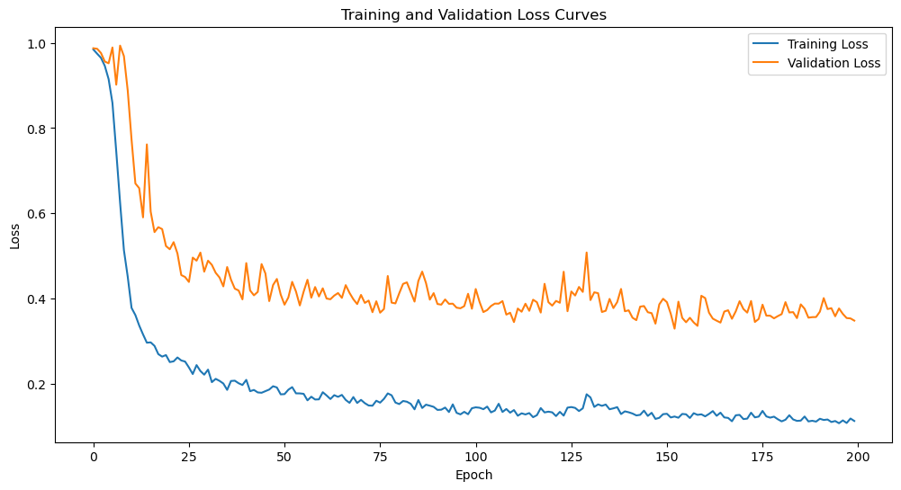

Figure 11

Training – Validation Curve for Caries Detection Model

The Intersection over Union (IOU) curve mirrors the trend observed in the training-validation curves, peaking around the 75-100th epoch. Beyond this point, any subsequent increase in IOU scores may indicate a risk of overfitting, wherein the model becomes overly specialized to the training data and may struggle to generalize to unseen data.

IOU scores of 0.5 and higher typically signify good model performance, indicating a significant overlap between the predicted and ground truth segmentation masks. Notably, one of our models, as shown later, achieves IOU scores exceeding this threshold.

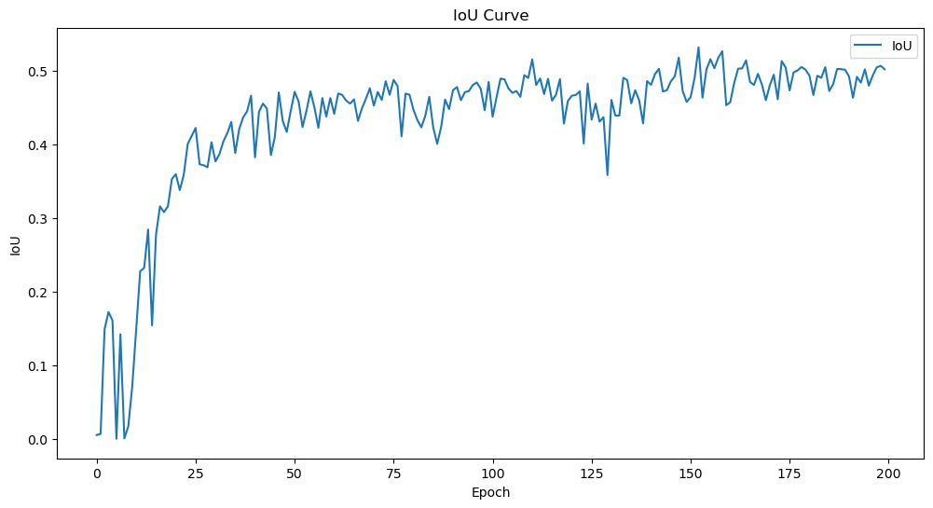

Figure 12

IOU Curve of Caries Detection Model

The experimental outcomes for the caries detection models as shown in Table I reveal different performances across different architectural configurations. Notably, the U-Net EfficientNet-b0 model exhibited the highest Intersection over Union (IOU) at 0.5422, Precision at 0.7613, and Dice coefficient at 0.6865. This superior performance can be attributed to the effective fusion of low-level and high-level features enabled by the EfficientNet-b0 backbone, contributing to more accurate segmentation.

While ResNet34 is known for its deeper architecture, its performance may be impacted by the specific characteristics of the caries detection task, suggesting that the dataset is not large enough to benefit from the increased network depth.

The U-Net++ model with the EfficientNet-b0 architecture showcased competitive results, with an IOU of 0.4658, Precision of 0.7489, and Dice coefficient of 0.6030. This model’s incorporation of full-scale skip connections and deep supervisions contributes to improved feature representation, balancing between complexity and performance.

The U-Net EfficientNet-b0 model emerges as the most promising candidate, surpassing its counterparts in IOU, Precision, and Dice coefficient. The efficient fusion of features in the U-Net EfficientNet-b0 architecture proves advantageous for accurate segmentation. These results as shown in table 2 emphasize the importance of tailoring the model architecture to the specific demands of the segmentation task, and in this context, the EfficientNet-b0 backbone stands out as particularly effective.

Table 2

Comparison Of Model Metrics for Caries Detection

|  |  |  |  |  |
| --- | --- | --- | --- | --- |
| ARCHITECTURE | MODEL | IOU | PRECISION | DICE |
| U-NET | EFFECIENTNET-B0 | 0.5422 | 0.7613 | 0.6865 |
| U-NET | RESNET34 | 0.4516 | 0.6911 | 0.5917 |
| U-NET++ | EFFECIENTNET-B0 | 0.4658 | 0.7489 | 0.6030 |

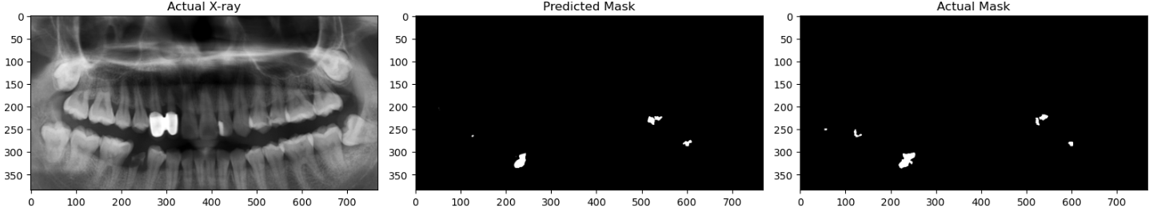

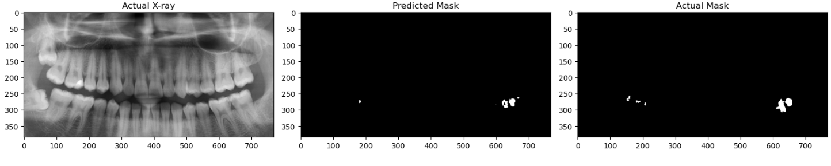

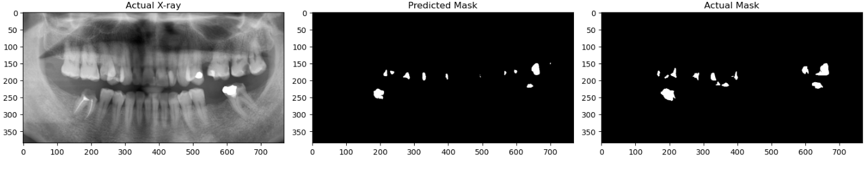

Figure 13

Model Performance After Training

Figure 13 depicts the performance of our models post-training, showcasing their proficiency in detecting both major and minor caries present in the radiograph images. While the models demonstrate commendable performance overall, there are instances where they fail to detect minor caries or accurately delineate the shape and outline of the caries. This limitation can be attributed to the lack of diversity within the training dataset, which may hinder the model's ability to learn nuanced features and achieve precise segmentation. To address this challenge and enhance model performance, a larger dataset comprising a wide range of caries cases, including both mild and extreme instances, along with meticulously segmented caries regions, is imperative. By exposing the model to a more diverse array of examples, it can learn to recognize and accurately segment the finer details of caries lesions, thereby improving its overall effectiveness in dental caries detection and diagnosis.

The figure 14 shows a practical application of our model, where a radiograph image serves as input to our system, swiftly generating a segmented mask highlighting potential caries within the patient's teeth. This streamlined process offers invaluable assistance in diagnosing dental conditions and guiding subsequent treatment strategies. Particularly noteworthy is the model's capability to detect and delineate minor caries, which may evade detection by the human eye alone. By providing a visual representation of caries lesions, our model facilitates more accurate diagnosis and enables timely intervention, ultimately contributing to improved patient care and dental health outcomes.

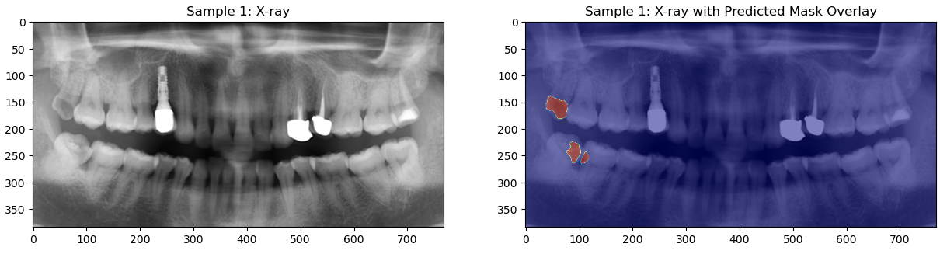

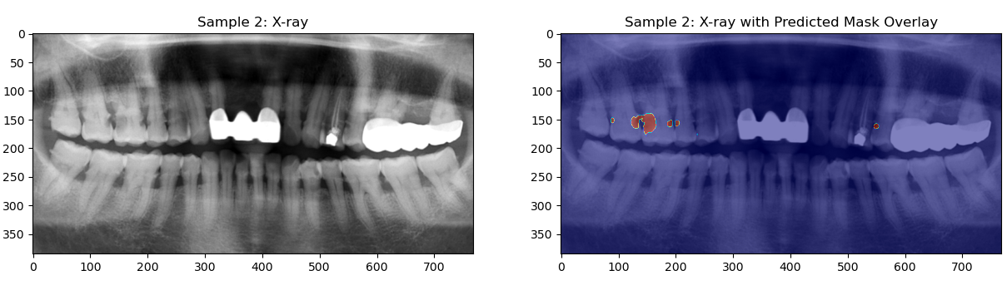 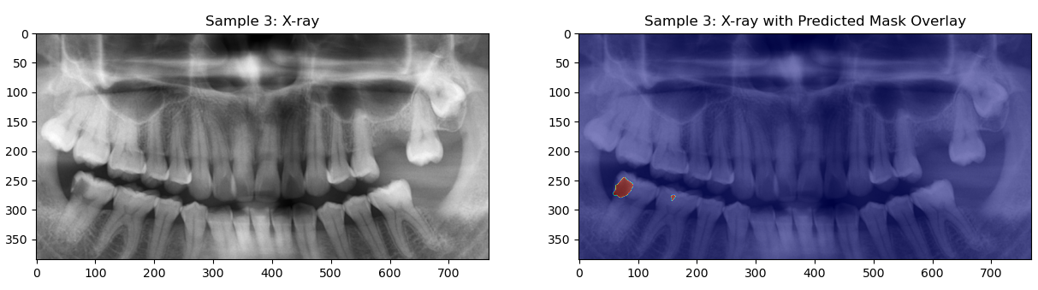

Figure 14

Caries Detection Showcase for Realtime use

**Chapter 5**

**Conclusion and Future Work**

5.1 CONCLUSION

The tooth segmentation and caries detection model present a significant advancement in enhancing dental diagnostic processes and subsequent treatment strategies. Current research often relies on large proprietary datasets and custom-built models tailored for segmentation tasks which are difficult to train and maintain. However, our study demonstrates an alternative approach by leveraging transfer learning techniques, coupled with image augmentation methods and modified architectures incorporating skip-layer excitation’s. This method has proven to be efficient in developing models capable of achieving accurate segmentation results when data available is scarce.

Our model's proficiency in tooth segmentation lays the groundwork for a multitude of clinical applications, ranging from treatment planning and orthodontic assessments to forensic odontology. By providing clinicians with detailed and comprehensive tooth segmentations, our model empowers them to make more informed decisions and deliver personalized treatment plans tailored to each patient's unique dental morphology and pathology. Additionally, the automation of tooth segmentation reduces the burden on clinicians, allowing them to allocate more time and resources to patient care and consultation.

In addressing the challenge of caries segmentation, we encountered the inherent limitation of working with a relatively small dataset. Recognizing the importance of data diversity in training robust deep learning models, we implemented transfer learning as a strategy to overcome this constraint. By leveraging pre-trained encoder models and fine-tuning them on our dataset, we effectively augmented our training data and facilitated the learning process for our caries segmentation model. This approach enabled our model to capture a wide range of caries variations and nuances, ultimately enhancing its ability to generalize and accurately segment caries lesions from radiographic images.

Despite the inherent challenges posed by the small dataset, our caries segmentation model yielded promising results. After training, we observed the model's capability to detect both major and minor caries lesions with a high degree of accuracy. While there were instances where the model struggled to detect minor caries or precisely map out the contours of caries lesions, these limitations were attributed to the lack of diversity within the training dataset. Nonetheless, our model's performance surpassed expectations, showcasing its potential as a valuable tool in aiding dental professionals in caries detection and diagnosis.

Moving forward, further efforts will be directed towards addressing the limitations associated with the small dataset and refining our caries segmentation model. This includes expanding the dataset to encompass a broader spectrum of caries cases, ranging from mild to severe instances, and meticulously annotating caries lesions to provide the model with more comprehensive training data.

Ongoing optimization of model architecture and hyperparameters will be pursued to enhance segmentation accuracy and robustness. By continuously iterating and refining our approach, we aim to further elevate the performance of our caries segmentation model and contribute to advancements in dental image analysis and patient care.

5.2 FUTURE WORK

In future work, several avenues for improving the performance and applicability of our models can be explored. One potential approach is the utilization of Generative Adversarial Networks (GANs) to synthesize additional dental images, thereby expanding the dataset size and enhancing the robustness of our U-Net models. By generating synthetic images that closely resemble real radiographic data, we can provide our models with more diverse training examples, ultimately improving their ability to generalize and accurately segment dental structures and caries lesions.

Additionally, while our models were trained on publicly available datasets, accessing larger and more diverse datasets from local medical hospitals or research facilities could yield promising results. However, navigating the ethical and legal complexities surrounding patient confidentiality and privacy may pose challenges in acquiring such datasets. Collaborating with medical professionals and institutions to address these concerns and establish data-sharing protocols will be crucial in expanding our dataset and improving the performance of our models.

Furthermore, while our models were evaluated using standard metrics, such as accuracy and Intersection over Union (IOU), involving medical professionals to assess segmented images can provide valuable insights and ensure the clinical relevance of our models. By soliciting expert feedback and validation, we can enhance the reliability and interpretability of our segmentation results, ultimately increasing the confidence of clinicians in utilizing our models for diagnostic purposes.

The performance of our models is intrinsically linked to the hardware resources available for training. We utilized the free compute resources provided by various cloud platforms that enabled the development and training of our models. However, this necessitated a reduction in the dimensionality and resolution of the radiographs used in training to accommodate computational limitations and expedite model fitting.

In a more realistic setting, where hardware constraints are less prohibitive, the same models could be trained on higher resolution images. This approach would mitigate the limitations imposed by reduced resolution, thereby allowing the model to capture finer details present in radiographs. Consequently, the model's performance would likely improve, as it gains the ability to discern and learn from subtle nuances inherent in higher resolution images.

It is essential to emphasize that our models are intended to serve as aids to clinicians, rather than replacements. As such, future work should focus on integrating our models seamlessly into clinical workflows, prioritizing patient safety, and ensuring ethical use of AI technology in healthcare.

**REFERENCES**

[1] J D B Featherstone. Dental caries: a dynamic disease process. Aust. Dent. J., 53(3):286–291, September 2008.

[2] Shinae Lee, Sang-Il Oh, Junik Jo, Sumi Kang, Yooseok Shin, and Jeong-Won Park. Deep learning for early dental caries detection in bitewing radiographs. Sci. Rep., 11(1):16807, August 2021.

[3] Gil Jader, Jefferson Fontineli, Marco Ruiz, Kalyf Lima, Matheus Pithon, and Luciano Oliveira. Deep instance segmentation of teeth in panoramic x-ray images. pages 400–407, 10 2018.

[4] Jae-Hong Lee, Do-Hyung Kim, Seong-Nyum Jeong, and Seong-Ho Choi. Detection and diagnosis of dental caries using a deep learning-based convolutional neural network algorithm. J. Dent., 77:106–111, October 2018.

[5] Luya Lian, Tianer Zhu, Fudong Zhu, and Haihua Zhu. Deep learning for caries detection and classification. Diagnostics (Basel), 11(9):1672, September 2021.

[6] Yifan Zhang, Fan Ye, Lingxiao Chen, Feng Xu, Xiaodiao Chen, Hongkun Wu, Mingguo Cao, Yunxiang Li, Yaqi Wang, and Xingru Huang. Children’s dental panoramic radiographs dataset for caries segmentation and dental disease detection. Sci. Data, 10(1):380, June 2023.

[7] Agnieszka Mikołajczyk and Michał Grochowski. Data augmentation for improving deep learning in image classification problem. In 2018 International Interdisciplinary PhD Workshop (IIPhDW), 2018.

[8] Hee E Kim, Alejandro Cosa-Linan, Nandhini Santhanam, Mahboubeh Jannesari, Mate E Maros, and Thomas Ganslandt. Transfer learning for medical image classification: a literature review. BMC Med. Imaging, 22(1):69, April 2022.

[9] Olaf Ronneberger, Philipp Fischer, and Thomas Brox. U-net: Convolutional networks for biomedical image segmentation, 2015.

[10] Swaminathan Sivagami, P. Chitra, G. Sri, Ram Kailash, and S. R. Muralidharan. Unet architecture based dental panoramic image segmentation. 2020 International Conference on Wireless Communications Signal Processing and Networking (WiSPNET), pages 187–191, 2020.

[11] Md Zahangir Alom, Chris Yakopcic, Mahmudul Hasan, Tarek M Taha, and Vijayan K Asari. Recurrent residual U-Net for medical image segmentation. J. Med. Imaging (Bellingham), 6(1):014006, January 2019.

[12] Huimin Huang, Lanfen Lin, Ruofeng Tong, Hongjie Hu, Qiaowei Zhang, Yutaro Iwamoto, Xianhua Han, Yen-Wei Chen, and Jian Wu. Unet 3+: A full-scale connected unet for medical image segmentation, 2020.

[13] Xianyun Wang, Sizhe Gao, Kaisheng Jiang, Huicong Zhang, Lin-Hu Wang, Feng Chen, Jun Yu, and Fan Yang. Multi-level uncertainty aware learning for semi-supervised dental panoramic caries segmentation. Neurocomputing, 540:126208, 2023.

[14] Connor Shorten and Taghi Khoshgoftaar. A survey on image data augmentation for deep learning. Journal of Big Data, 6, 07 2019

.  
[15] Chenxi Huang, Jiaji Wang, Shuihua Wang, and Yudong Zhang. A review of deep learning in dentistry. Neurocomputing, 554:126629, 2023.

[16] Hao Ding, Jiamin Wu, Wuyuan Zhao, Jukka Matinlinna, Michael Burrow, and James Tsoi. Artificial intelligence in dentistry—a review. Frontiers in Dental Medicine, 4:1085251, 02 2023.

[17] Zongwei Zhou, Md Mahfuzur Rahman Siddiquee, Nima Tajbakhsh, and Jianming Liang. Unet++: A nested u-net architecture for medical image segmentation. CoRR, abs/1807.10165, 2018.

[18] Ramzi Ben Ali, Ridha Ejbali, and Mourad Zaied. Detection and classification of dental caries in x-ray images using deep neural networks. In International Conference on Software Engineering Advances, 2016.

[19] Senbao Hou, Tao Zhou, Yuncan Liu, Pei Dang, Huiling Lu, and Hongbin Shi. Teeth U-Net: A segmentation model of dental panoramic x-ray images for context semantics and contrast enhancement. Comput. Biol. Med., 152(106296):106296, January 2023.

[20] Chen Sheng, Lin Wang, Zhenhuan Huang, Tian Wang, Yalin Guo, Wenjie Hou, Laiqing Xu, Jiazhu Wang, and Xue Yan. Transformer-based deep learning network for tooth segmentation on panoramic radiographs. J. Syst. Sci. Complex., 36(1):1–16, October 2022.

[21] Lubaina T Arsiwala-Scheppach, Akhilanand Chaurasia, Anne Müller, Joachim Krois, and Falk Schwendicke. Machine learning in dentistry: A scoping review. J. Clin. Med., 12(3):937, January 2023

**APPENDICES**



* 1. CODE SNIPPETS

1.1.1TOOTH SEGMENTATION MODEL

The code for image pre-processing and augmentation used in the tooth segmentation model is given below:





The code for the convolution, encoder and decoder used for the U-Net model is given below:





The code for the generator and the discriminator is given below:







1.1.2 CARIES DETECTION MODEL

The code image augmentation and pre-processing used in the caries dataset is given below:





Various Loss Function and metrics that were utilized during model training was calculated using the code snippet below.







Model Training and Loss calculations was done using the below code, various metrics would be printed at each epoch to showcase the model’s capabilities as we train.





* 1. DATA SAMPLES

The sample images included in the appendix encompass a range of input radiographic images, segmented masks, and model predictions obtained during the course of the study. These images showcase the diversity and complexity of the dataset used for training and validation, as well as the effectiveness of the segmentation models in accurately delineating dental structures and caries lesions.

We also include several of the model’s predictions, its input images, and the correct masks for the reader’s further understanding of our model’s performance.

* + 1. TOOTH SEGMENTATION MODEL

A subset of the images, we are working with for segmentation, The dataset contains a variety of cases, ranging from missing tooths to abnormalities, growths and other lesions which can help the model learn and generalize better.

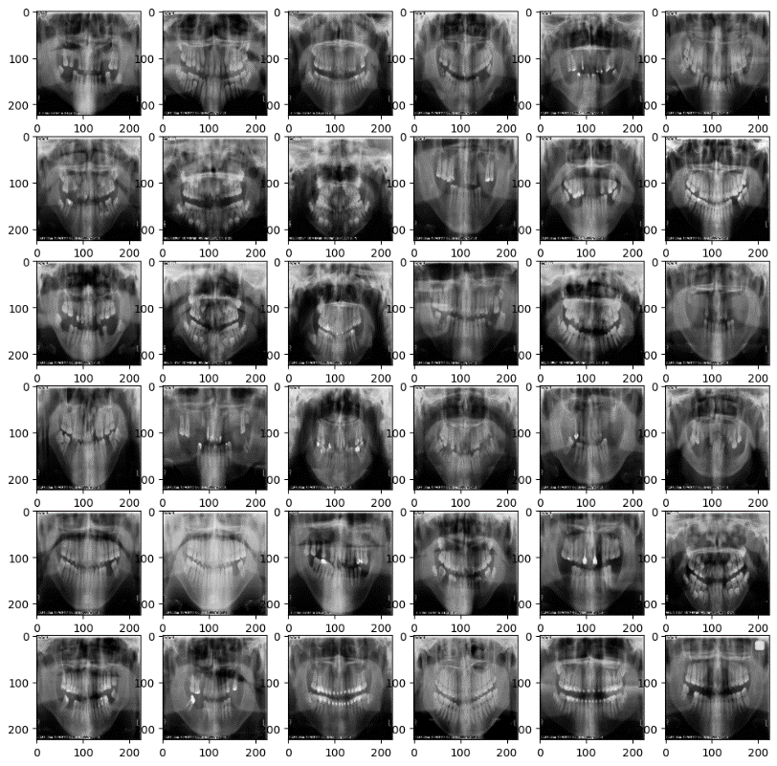

Figure 1

With the mask superimposed on the radiographic image, the boundaries of individual teeth are delineated with greater precision, allowing for improved visualization and interpretation by dental professionals.

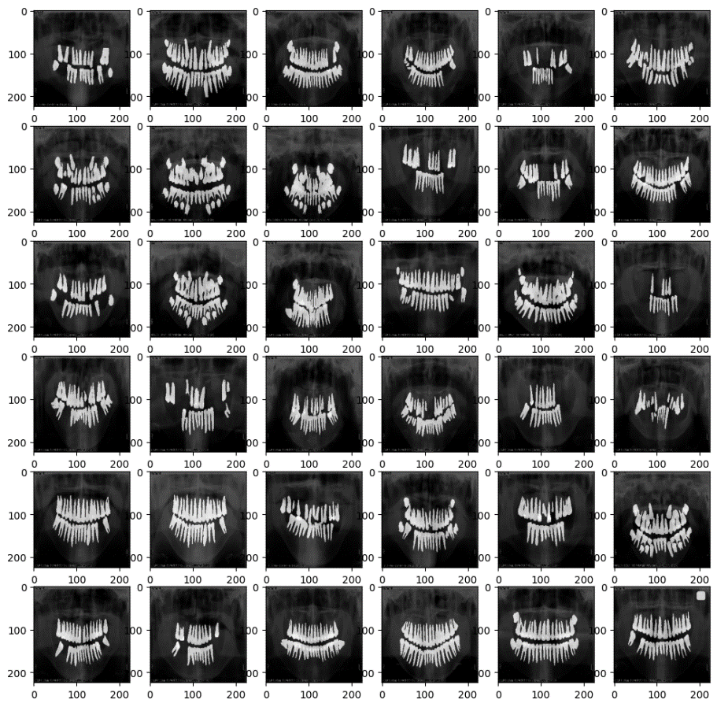

Figure 2

The plot below presents a brief architectural diagram, generated using TensorFlow's built-in function, showcasing the constraints and operational framework of the GAN model. Notably, the diagram illustrates how due to hardware limitations, image size has been constrained to a smaller resolution.

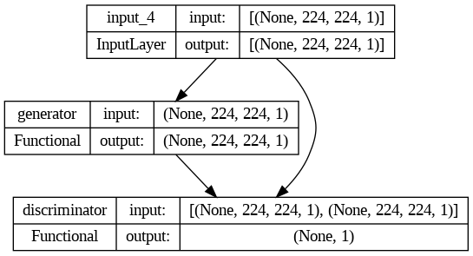

Figure 3

Finally, we present a selection of sample images demonstrating the performance of the models, showcasing their predictions alongside the correct segmented images. Both segmentations have been overlaid onto the radiograph image to provide a clearer depiction of the model's capabilities in a real-world use-case scenario. These sample images serve to illustrate the effectiveness of the models in accurately segmenting dental structures and caries lesions, facilitating improved visualization and interpretation by dental professionals.

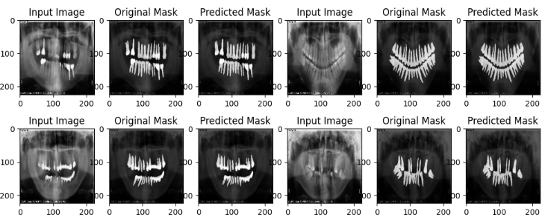

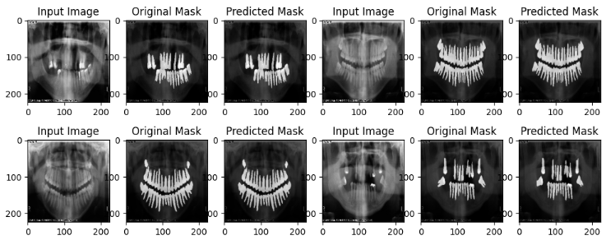

Figure 4

* + 1. CARIES DETECTION MODEL

The following are some sample images showcasing our model’s abilities. We have chosen a diverse set of images to show its capabilities, however the overall performance and ability will improve with a better and more diverse dataset for it to train on.

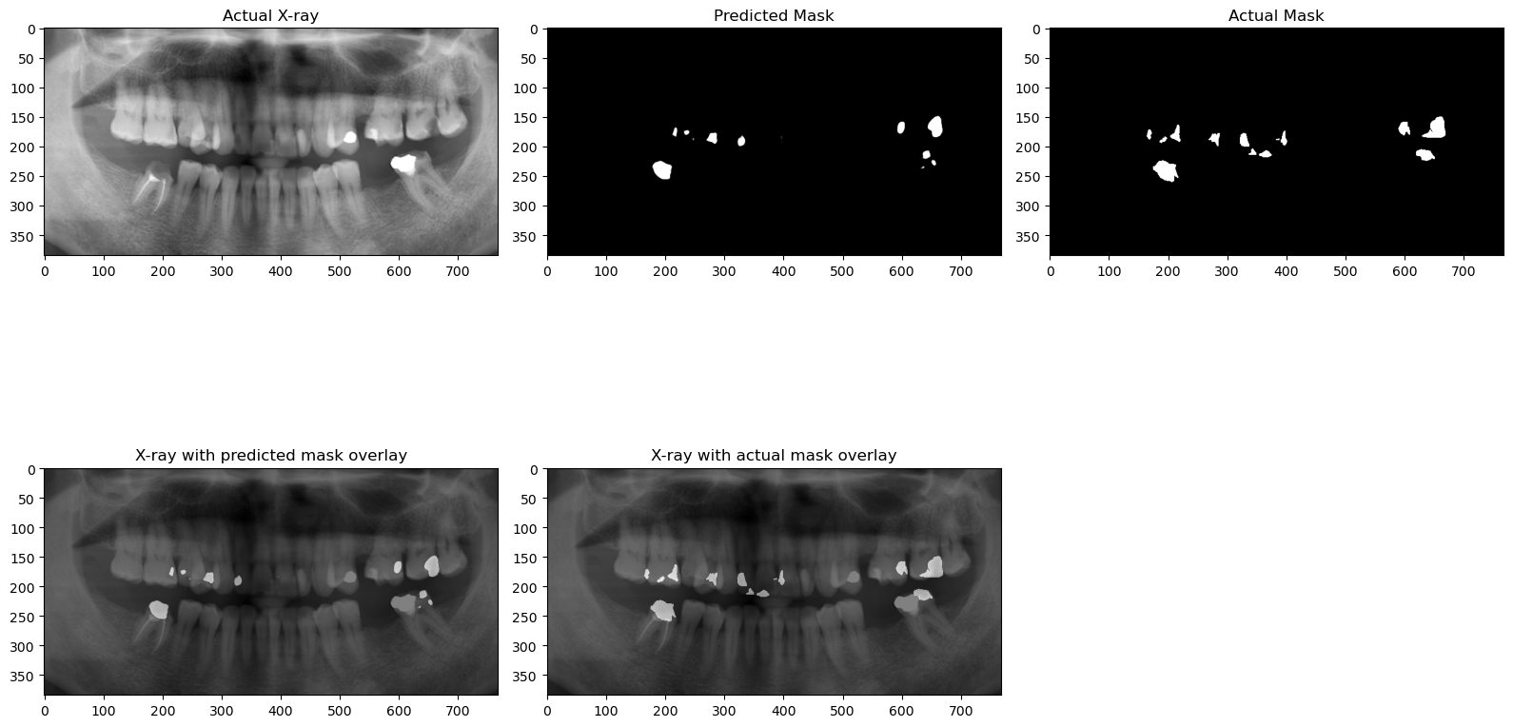

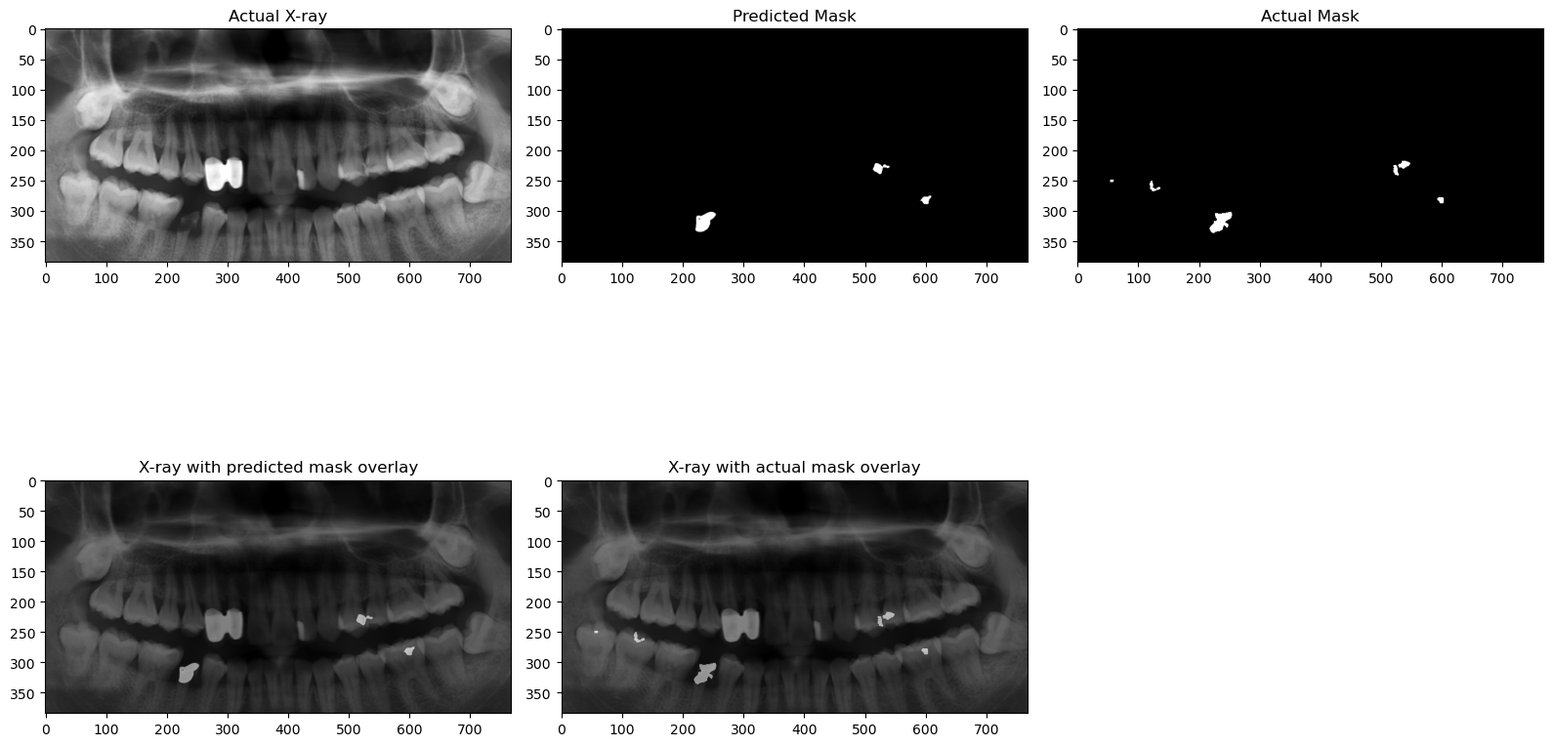

Figure 6

A more realistic use-case is depicted below, our model can generate the segmented mask and display the caries within a few seconds of passing the input radiograph as input. We have utilized a colormap on the predicted image, to accentuate the features and make it easier for the reader to visualize the caries (marked in red).

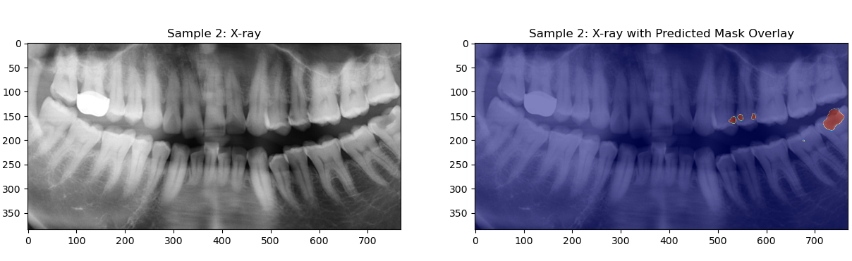

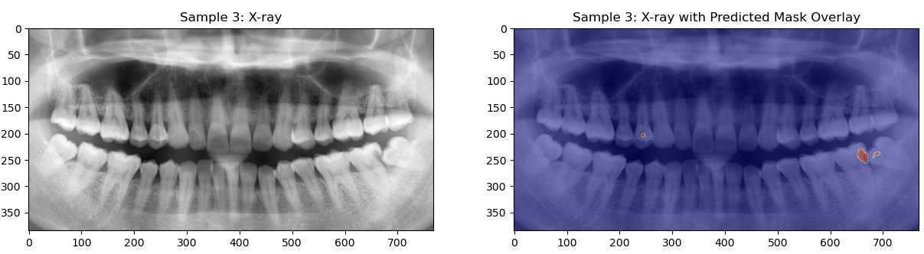

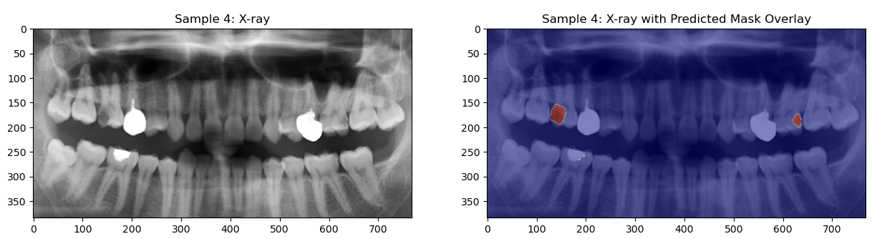

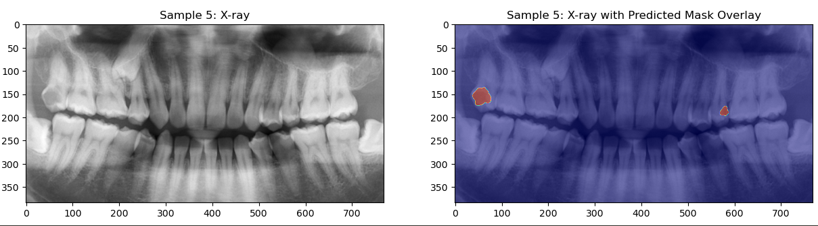

Figure 7